# Exercises: Bug Tracking Systems

## Create GitHub Repository

### Task 1. Register to GitHub

Skip this step if you already have an account

1. Go to <https://github.com/>
2. Register an account
3. Log into the account

### Task 2. Create new repository

After you have successfully logged into your GitHub account follow the steps below

1. Click on the “+” on the upper right corner and click “New repository”

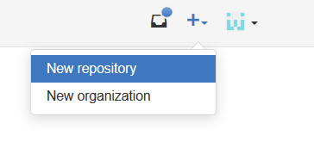

1. Choose appropriate repository name e.g. “QA-Course” and a description. Initialize the repository with a README.

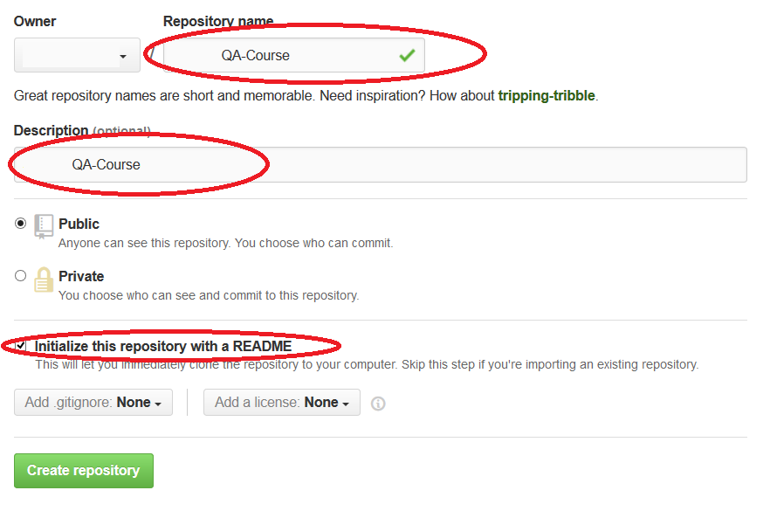

1. Click “Create repository”

## Play with GitHub Issues

### Task 1. Create new issue

After you are in your newly created repository follow the steps below

1. Go to Issues from the right-side menu
2. Click “New Issue”
3. Write a simple issue, label it as a bug and assign it to yourself

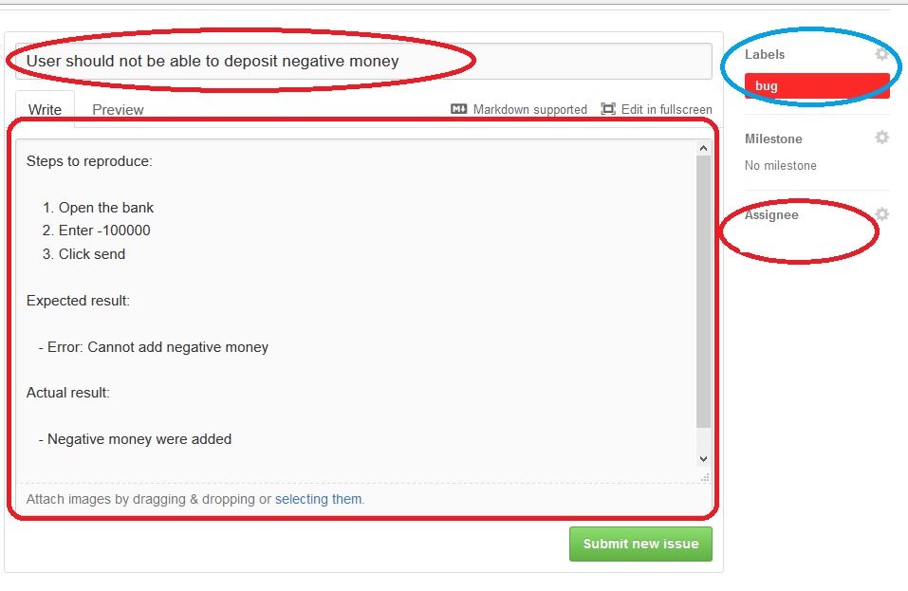

1. Click “Submit new issue”

### Task 2. Create issue linked to a problem

1. Commit a file to the repository
2. Create new issue labeled as a bug
3. Change something to the file and commit the changes. In the commit message refer to the issue ID in the format “#issueId – some message here” e.g. “#5 – fixed negative money bug”
4. You can find the issue id when you open the issue and look at its title (the number after the # sign)

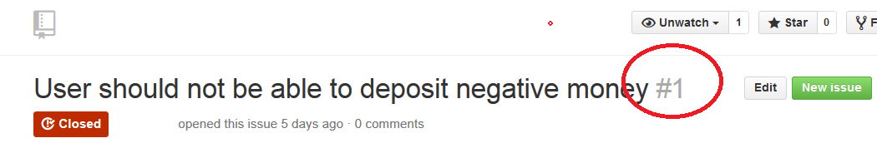

1. Check if it’s linked in the commits section

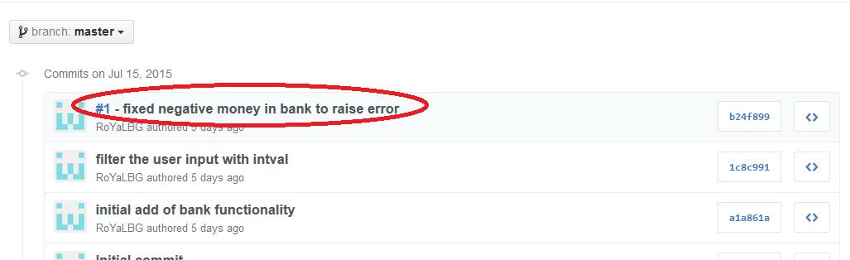

1. Check if It’s linked in the issue

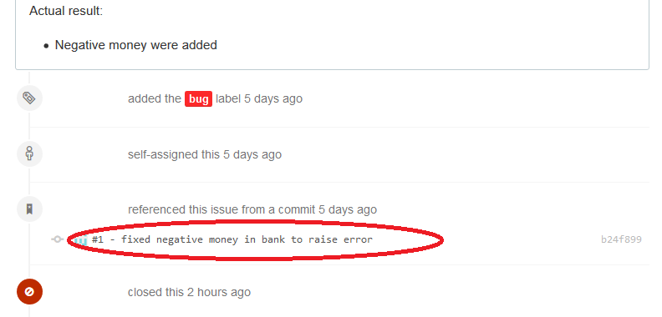

1. Close the issue